## Garden management

1. **Virtual reality and 3D simulation technology applications**: The paper “Virtual Reality Design and Implementation of Interactive Garden Landscapes” demonstrates the application of virtual reality technology in garden landscape design, emphasizing the importance of 3D models and real-time rendering. The study uses the OpenSceneGraph graphics rendering engine to visualize 3D landscape models and parameter control of spatial layouts, which provides users with an interactive 3D scene browsing experience that is very suitable for your platform.
2. **GIS and multi-sensor technology**: In the paper “Application of GIS and multi-sensor technology in green urban garden landscape design,” GIS technology is used for data query and analysis, terrain analysis, hydrological analysis, etc. These technologies can help users to process and display geographic information more accurately when designing gardens, thereby improving the accuracy and practicality of the design.
3. **Three-dimensional simulated garden landscape design method**: The paper “Three-dimensional simulated garden landscape design method based on virtual simulation technology” studies the combination of virtual simulation technology and the traditional three-dimensional simulated garden landscape design method. By constructing a three-dimensional garden landscape simulation system, the accuracy of the design method is improved, which provides technical support for designing more detailed and vivid garden landscapes.

There are **three related technologies in garden design** that shows our function is reasonable:

1. VR

allows users to view and interact with the garden environment in real time, so as to better understand the layout and design intent（Zhang, Song, & QuanQi, 2021）.

2. GIS and Multisensor Technology

GIS technology integrates and manages large amounts of spatial data through a geographic information system, helping designers to conduct precise terrain analysis, location analysis and ecological assessment（Shen, 2023）.

3. 3D

has constructed a complete 3D garden landscape simulation system, which realizes the whole process of digitalization from sketch to detailed design, including terrain design, planning design and plant layout, etc ( Chen & Wang, 2022）.

The application of these technologies has made garden and landscape design more precise, interactive and customer-friendly, greatly improving the quality of design and user satisfaction.

which shows our function is resonable

In terms of **social aspects**,

we found an app called Meals for Monsters:

users can choose their favorite monsters and select what they think is a healthy meal for them to help them achieve their health goals. At the same time, everyone can see the choices and reasons of other users, thus promoting mutual learning and knowledge sharing (Olinsky et al., 2021).

.

This way of working together to achieve goals has inspired our project. like we design together and share the ideas.

Another paper wrote that through the observation of several gardeners of different ages, it was found that without direct interaction, they adjusted their gardens through observation and imitation, gaining experience and knowledge (Maddali, 2020).

**other relative research:**

**CoAug-MR**

The literature proposes the use of Hololens and motion tracking devices for real-time design feedback and evaluation, and to allow users to experience prototyping in physical space. The research also incorporates user posture, preferences and the environment into the design, and the usability of the system is evaluated through an interaction design process involving both regular users and designers.

**VR Four-Person Rowing Task**

This study aimed to assess the teamwork ability of a four-person team through a tactile collaborative task and to distinguish the individual contributions of each member. A rowing task in a haptic virtual environment was designed to simulate rowing in a boat, requiring the four members to row in unison to follow a target curve. Eight teamwork indicators were defined based on the rowing trajectory and the synchrony of the four members' rowing movements. These indicators were finally combined into a composite feature, and the correlation between this feature and the members' self-rated teamwork ability was analyzed. The results showed a high positive correlation (r > 0.8) between the composite feature and teamwork ability.

**Multi-person collaborative Simulation System for Subway Emergency**

This article proposes a multi-person collaborative emergency simulation system based on virtual reality in response to the current lack of equipment and means in joint emergency drills at urban rail stations. A large-scale virtual reality scene is constructed using a viewpoint-related LOD quadtree, and Socket technology is used to enable online interaction between multiple people.

**3D Visualization Techniques Accessible for Day-To-Day Team-Science Collaboration and Analysis**

A collaborative framework that supports collaboration across different visualization methods is introduced to facilitate multi-person collaboration in team science. By combining narrative techniques and spatial annotation capabilities, the framework enables users to generate data stories using spatial 3D visualization and distribute them to different client applications and plug-ins for interdisciplinary discussions through flexible export of results.

**Relative website:**

**Planner 5D**

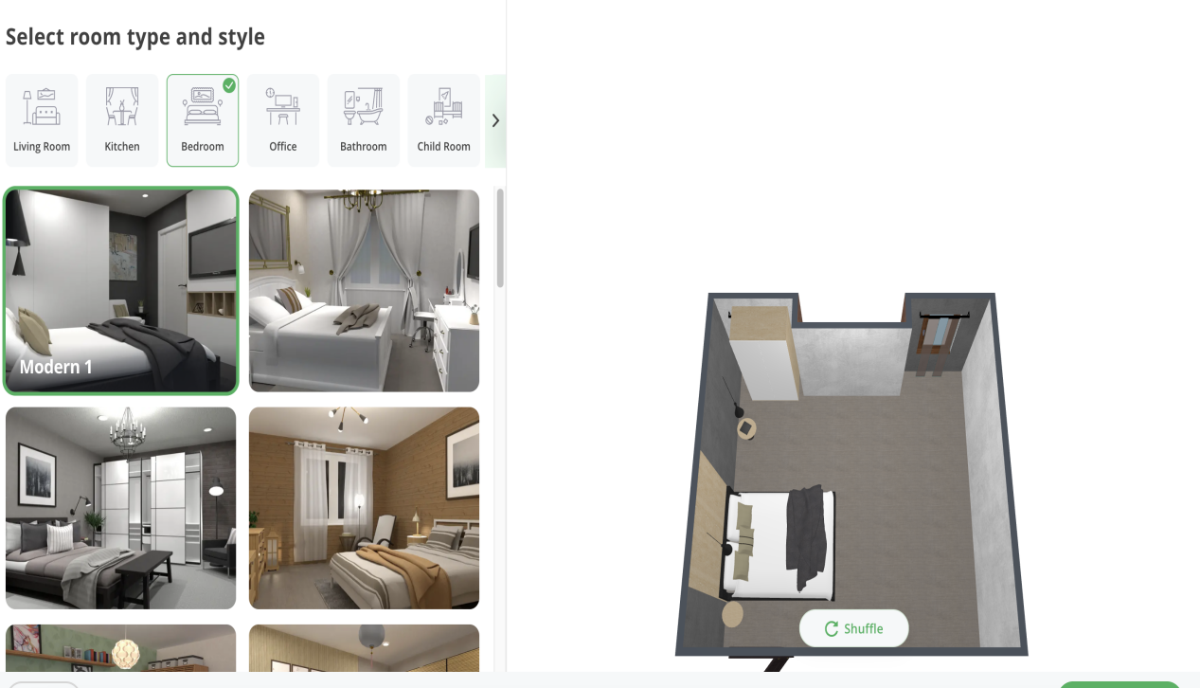

Place some furniture models in the area to see the effect.

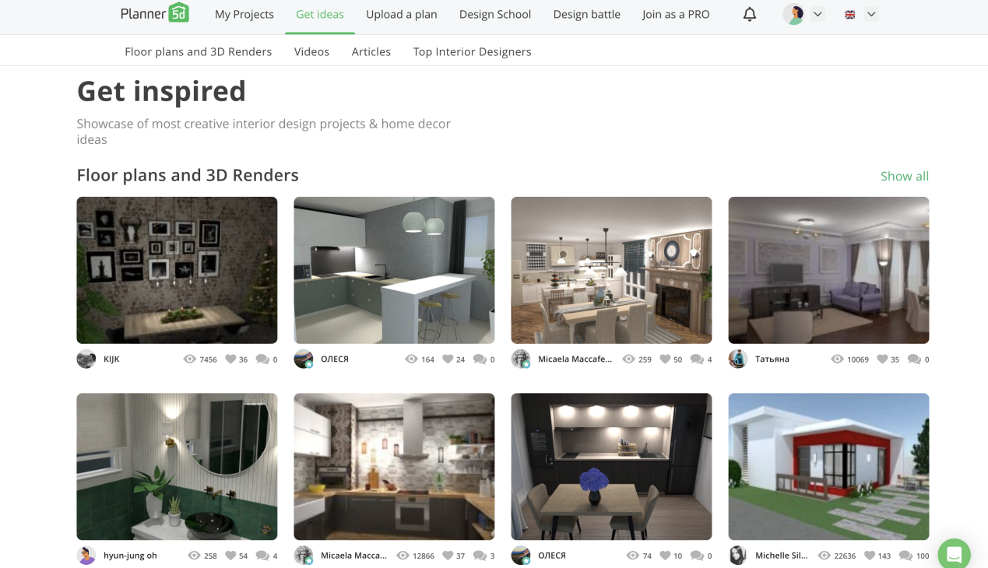

Provide garden design ideas

**Neighborbrite —— AI yard**

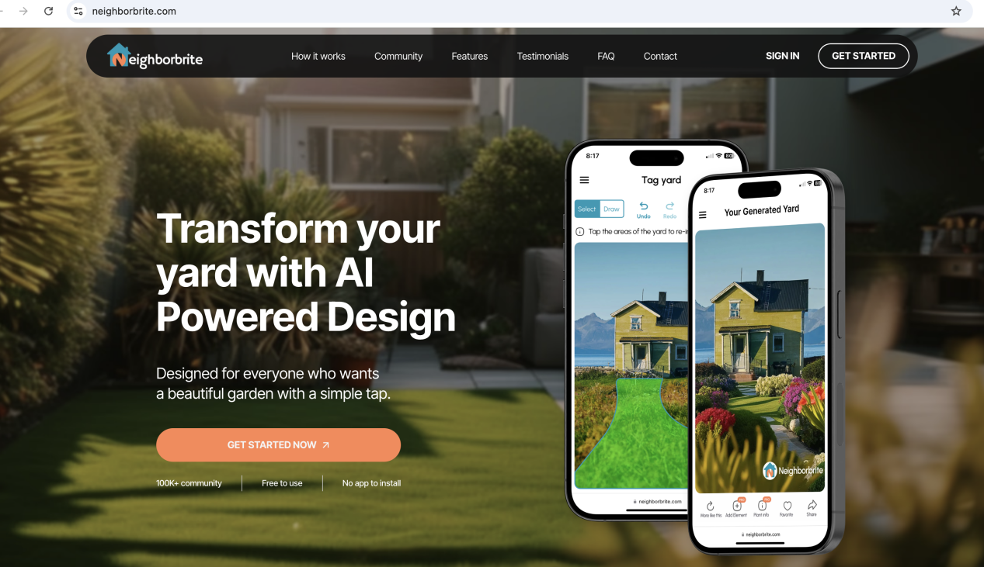

Use AI to generate a suitable garden design

Provides garden design methods, what should pay attention to in different gardens, and the tools and materials needed to complete the design.

**Garden Design**

****

**Gardensillustrated**



Reference:

Zhang, X., Song, Y., & QuanQi, S. (2021). Virtual Reality Design and Realization of Interactive Garden Landscape. Complexity, 2021https://doi.org/10.1155/2021/6083655

Chen, S., & Wang, X. (2022). Three-Dimensional Simulation Garden Landscape Design Method Based on Virtual Simulation Technology. Wireless Communications & Mobile Computing (Online), 2022https://doi.org/10.1155/2022/4804256

Shen, D. (2023). Application of GIS and Multisensor Technology in Green Urban Garden Landscape Design. Journal of Sensors, 2023(1). <https://doi.org/10.1155/2023/9730980>

Olinsky, S., Desai, P. M., Heitkemper, E., Turkay, S., Mitchell, E. G., Mamykina, L., & Hwang, M. (2021). Meals for Monsters: a Mobile Application for the Feasibility of Gaming and Social Mechanisms. In CHI Conference on Human Factors in Computing Systems Extended Abstracts (CHI ’21 Extended Abstracts), May 8–13, 2021, Yokohama, Japan. ACM, New York, NY, USA, 9 pages. [https://doi.org/10.1145/3411763.3451789](https://doi.org/10.1145/3411763.3451789" \t "/Users/yinaoyan/Documents\\x/_new)

Maddali, H. T. (2020). Sociality and Skill Sharing in the Garden. Proceedings of the CHI Conference on Human Factors in Computing Systems, 1-17. [https://doi.org/10.1145/3313831.3376246](https://doi.org/10.1145/3313831.3376246" \t "/Users/yinaoyan/Documents\\x/_new)

Wang, L., & Yoon, K.-J. (2019). CoAug-MR: An MR-based Interactive Office Workstation Design System via Augmented Multi-Person Collaboration. arXiv (Cornell University). <https://doi.org/10.48550/arxiv.1907.03107>

Tian, B., Zheng, Y., Zhuang, Z., Luo, H., Zhang, Y., & Wang, D. (2024). Group Haptic Collaboration: Evaluation of Teamwork Behavior during VR Four-Person Rowing Task. IEEE Transactions on Haptics, 17(3), 384–395. https://doi.org/10.1109/TOH.2023.3346683

Jiang, T., Qiu, Y., & Li, F. (2020). A Multi-person collaborative Simulation System for Subway Emergency Based on Virtual Reality. IOP Conference Series: Materials Science and Engineering, 750(1), 12227. https://doi.org/10.1088/1757-899X/750/1/012227

Nam, J. W. (2022). Everyday Scientific Visualization: Making 3D Visualization Techniques Accessible for Day-To-Day Team-Science Collaboration and Analysis.